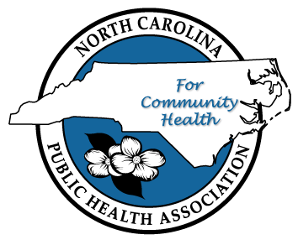
NCPHA Spring Advocacy Conference - Preserving the Public’s Health: A Day to Focus on Education and Advocacy

May 16, 2017
North Raleigh/Midtown Hilton

9:00 am – Registration and coffee

9:30 am - Opening Session
Joshua Swift, NCPHA President
Mandy Cohen, MD, Secretary, NC Department of Health and Human Services
Keynote by Dr. Andrew Taylor, Professor of Political Science, NCSU

10:45 am - Break

11:00 am – Plenary Session:
How a bill becomes a law (real life version vs the book version)
Pam Seamans, Former Policy Director at NC Alliance for Health
How to navigate the NCGA website and other online advocacy tools, Betsy Vetter, Regional VP of Government Relations, American Heart Association

11:55 am - Lunch
Aliana Havrilla, Community Coach, County Health Rankings and Roadmaps

Panel discussion with 3 professional lobbyists
Chip Baggett, Director, Legislative Relations, NC Medical Society
Maeve Gardner, Director, Government Relations, GSK
Joe Stewart, ED of NC FreeEnterprise Foundation

1:30 pm – Concurrent Sessions - the difference Branches of Government and the Impact each
has on policy
1. Legislative Branch – Former Representative Rick Glazier, ED of NC Justice Center
2. Executive Branch – Gary Fuquay, President, Fuquay Solutions
3. Judicial Branch – The Honorable Barbara Jackson, NC Supreme Court Associate Justice

Each session lasts 30 minutes so attendees can visit each session
1:30 – 2:00
2:15 – 2:45
3:00 – 3:30

3:30 pm - Closing Session
NC State Health Director (TBD)
Peg O’Connell, NCPHA Advocacy Chair
Joshua Swift, NCPHA President.

